utm Data analytics bootcamp  
COVID-19 vs. Stock Market

2020-06-07

# Overview

## Team Members

|  |  |
| --- | --- |
|  | 1. Matthew Duong 2. Avinash Dhawan 3. Shreya Sachdev 4. Jasmeet Aujila |

## Project Description/Outline

|  |  |
| --- | --- |
|  | While the toilet paper and hand sanitizer kerfuffle has abruptly ended with Costco no longer accepting returns on these once so-called hot commodities, COVID-19 continues to wreak havoc upon the world economy during these unprecedented times; with the Dow Jones Industrial Average (DJI) sinking almost 10000 points from February 2020 to March 2020.  The DJI measures the daily price movements of 30 large American companies on the NASDAQ and New York Stock Exchange (NYSE) within all the major sectors of the economy, we believe the DJI is the perfect index to compare how the stock market is recovering. As the world begins to ease the lockdowns, we will show how each of the 30 companies fared and affected the DJI. |

## Team Member Tasks

|  |  |
| --- | --- |
|  | * Get datasets from Yahoo Finance (DJI and its 30 components) * Load datasets to MongoDB using Python Flask * Query the database to visualize the data in the following methods through HTML/CSS and JavaScript:   + Tables (jQuery)   + Graphs (Plotly)   + API (Python Flask)   + Read API/Display Data (JavaScript) * Build webpages |

## Datasets

|  |  |
| --- | --- |
|  | * Yahoo Finance:   + Quote: <https://finance.yahoo.com/quote/%5EDJI?p=%5EDJI>   + Chart: <https://finance.yahoo.com/chart/%5EDJ> |

## Charts

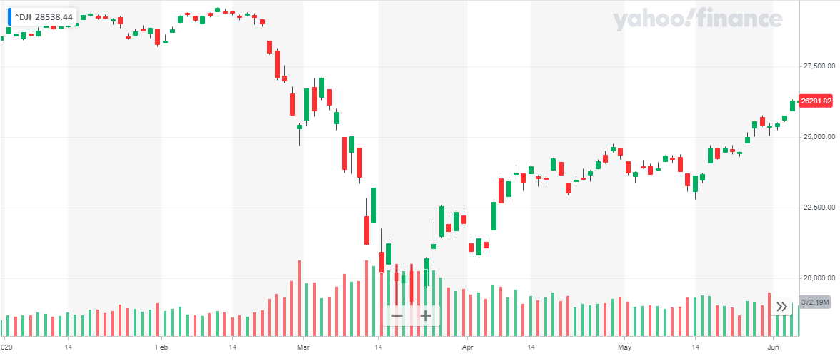

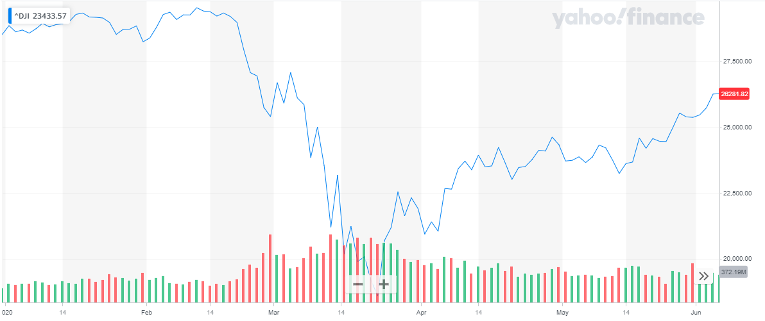

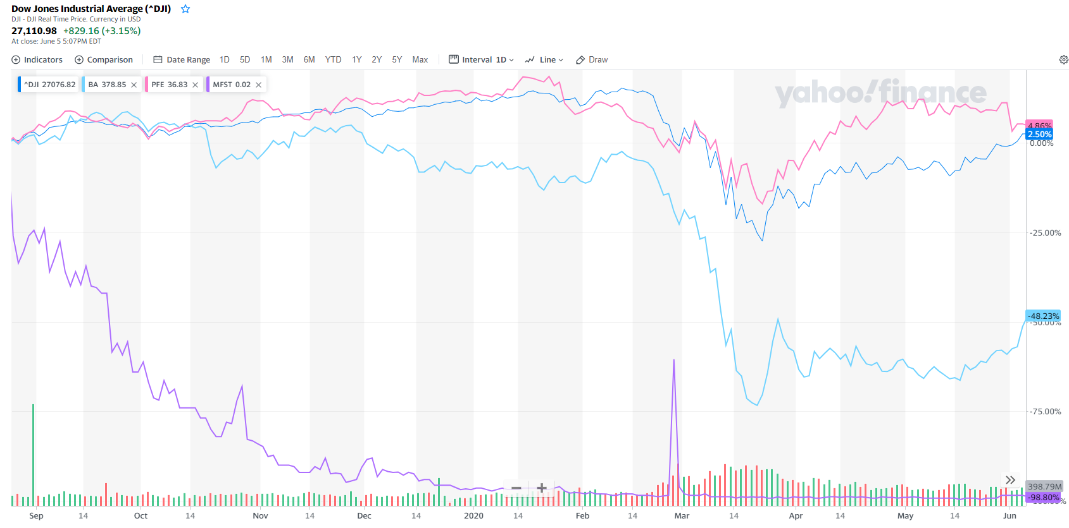

## Components

|  |  |  |
| --- | --- | --- |
| **Symbol** | **Company Name** | **Last Price (June 5, 2020)** |
| [PFE](https://finance.yahoo.com/quote/PFE?p=PFE) | Pfizer Inc. | 35.99 |
| [JNJ](https://finance.yahoo.com/quote/JNJ?p=JNJ) | Johnson & Johnson | 147.3 |
| [WMT](https://finance.yahoo.com/quote/WMT?p=WMT) | Walmart Inc. | 121.56 |
| [MRK](https://finance.yahoo.com/quote/MRK?p=MRK) | Merck & Co., Inc. | 82.26 |
| [VZ](https://finance.yahoo.com/quote/VZ?p=VZ) | Verizon Communications Inc. | 57.74 |
| [DIS](https://finance.yahoo.com/quote/DIS?p=DIS) | The Walt Disney Company | 124.82 |
| [NKE](https://finance.yahoo.com/quote/NKE?p=NKE) | NIKE, Inc. | 102.71 |
| [GS](https://finance.yahoo.com/quote/GS?p=GS) | The Goldman Sachs Group, Inc. | 217.92 |
| [PG](https://finance.yahoo.com/quote/PG?p=PG) | The Procter & Gamble Company | 118.33 |
| [MCD](https://finance.yahoo.com/quote/MCD?p=MCD) | McDonald's Corporation | 197.16 |
| [CSCO](https://finance.yahoo.com/quote/CSCO?p=CSCO) | Cisco Systems, Inc. | 47.83 |
| [INTC](https://finance.yahoo.com/quote/INTC?p=INTC) | Intel Corporation | 64.34 |
| [MSFT](https://finance.yahoo.com/quote/MSFT?p=MSFT) | Microsoft Corporation | 187.2 |
| [HD](https://finance.yahoo.com/quote/HD?p=HD) | The Home Depot, Inc. | 254.9 |
| [KO](https://finance.yahoo.com/quote/KO?p=KO) | The Coca-Cola Company | 49.09 |
| [IBM](https://finance.yahoo.com/quote/IBM?p=IBM) | International Business Machines Corporation | 132.06 |
| [WBA](https://finance.yahoo.com/quote/WBA?p=WBA) | Walgreens Boots Alliance, Inc. | 45.35 |
| [AAPL](https://finance.yahoo.com/quote/AAPL?p=AAPL) | Apple Inc. | 331.5 |
| [DOW](https://finance.yahoo.com/quote/DOW?p=DOW) | Dow Inc. | 43.97 |
| [MMM](https://finance.yahoo.com/quote/MMM?p=MMM) | 3M Company | 167.41 |
| [AXP](https://finance.yahoo.com/quote/AXP?p=AXP) | American Express Company | 109.73 |
| [V](https://finance.yahoo.com/quote/V?p=V) | Visa Inc. | 199.61 |
| [JPM](https://finance.yahoo.com/quote/JPM?p=JPM) | JPMorgan Chase & Co. | 111.23 |
| [UNH](https://finance.yahoo.com/quote/UNH?p=UNH) | UnitedHealth Group Incorporated | 311.85 |
| [CVX](https://finance.yahoo.com/quote/CVX?p=CVX) | Chevron Corporation | 100.81 |
| [CAT](https://finance.yahoo.com/quote/CAT?p=CAT) | Caterpillar Inc. | 135.12 |
| [TRV](https://finance.yahoo.com/quote/TRV?p=TRV) | The Travelers Companies, Inc. | 124.36 |
| [RTX](https://finance.yahoo.com/quote/RTX?p=RTX) | Raytheon Technologies Corporation | 72.07 |
| [XOM](https://finance.yahoo.com/quote/XOM?p=XOM) | Exxon Mobil Corporation | 53.08 |
| [BA](https://finance.yahoo.com/quote/BA?p=BA) | The Boeing Company | 205.43 |